Contents

Author : Santosh BM

Date : 26-DEC-2016

Azure machine learning studio

1. How to choose algorithms :

How to use the cheat sheet: Several data scientists I talked with said that Supervised
Supervised learning algorithms make predictions based on a set of examples.the only sure way to find the very best algorithm is to try all of them.
All of the modules in Azure Machine Learning are supervised learning algorithms. There are several specific types of supervised learning that are represented within Azure Machine Learning: classification, regression, and anomaly detection.
- Classification. When the data are being used to predict a category, supervised learning is also called classification. This is the case when assigning an image as a picture of either a 'cat' or a 'dog'. When there are only two choices, this is called two-class or binomial classification. When there are more categories, as when predicting the winner of the NCAA March Madness tournament, this problem is known as multi-class classification.
- Regression. When a value is being predicted, as with stock prices, supervised learning is called regression.
- Anomaly detection. Sometimes the goal is to identify data points that are simply unusual. In fraud detection, for example, any highly unusual credit card spending patterns are suspect. The possible variations are so numerous and the training examples so few, that it's not feasible to learn what fraudulent activity looks like. The approach that anomaly detection takes is to simply learn what normal activity looks like (using a history non-fraudulent transactions) and identify anything that is significantly different.
Unsupervised : Organizing unorganized data to get some structure or similarity between data
Considerations when choosing an algorithm
1.Accuracy
2.Training time
3.Linearity
Etc

2 .Broad view of algorithms :
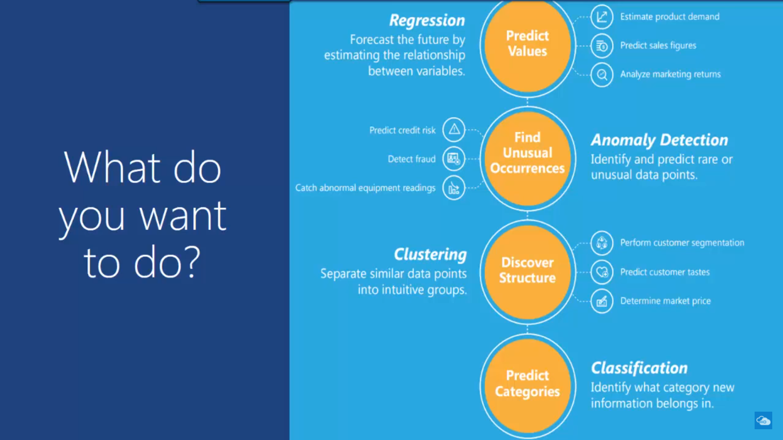
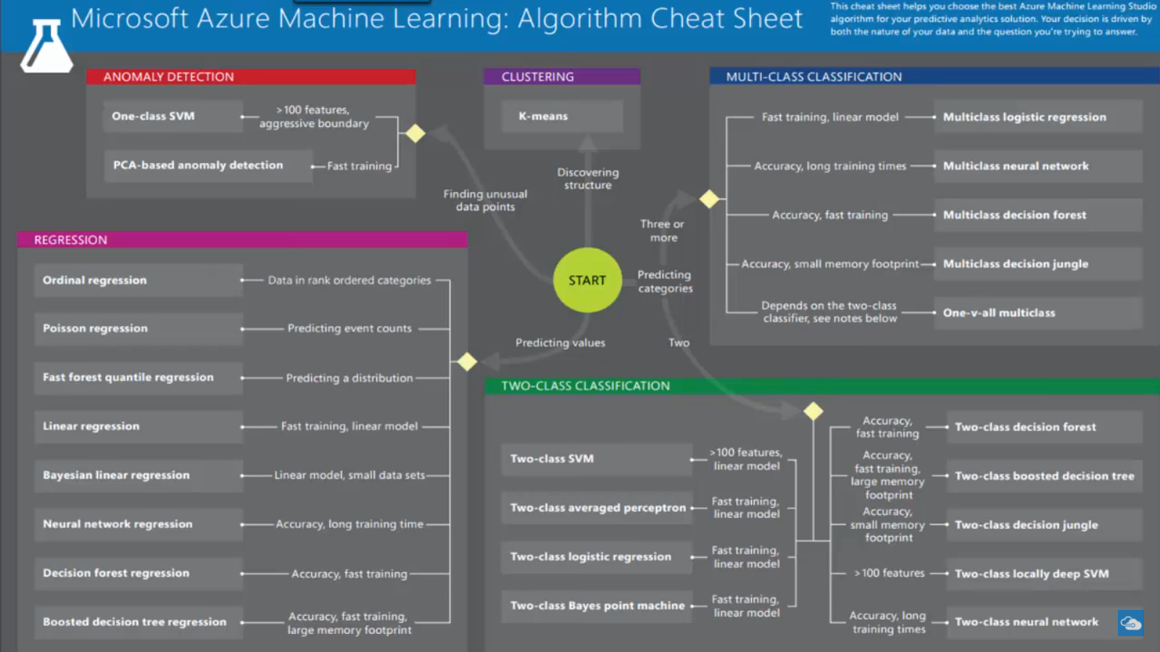

All in one slide:
http://carleton.ca/cuids/wp-content/uploads/microsoft-machine-learning-algorithm-cheat-sheet-v2.pdf
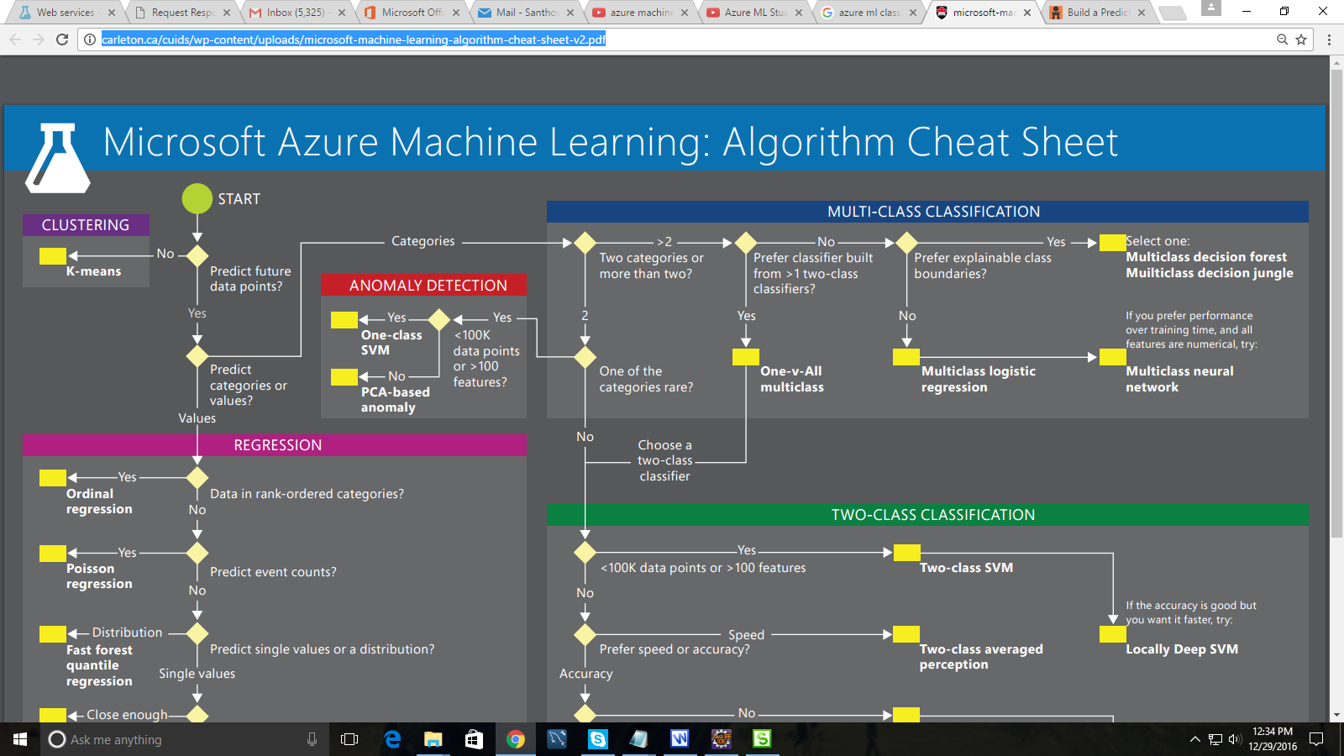

3 . Some useful terminologies on Data :

Feature : column used as input for training the model i.e input used for predicting the output

Label : Target parameter or column (Parameter to be predicted)

Categorical data : When numeric data represents some unique information instead of just a mathematical number . Ex: Zip code is number but we will not use for any mathematical operations , because each zip code represents different area . So it should be treated as Categorical data

